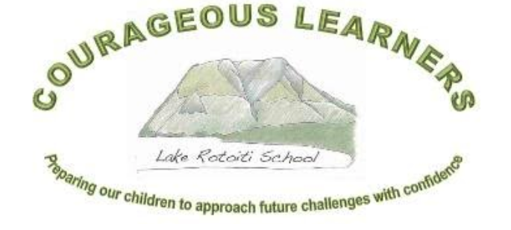

School Charter, Analysis of Variance, Strategic and Annual Plan
Lake Rotoiti School (3199)
2022 - 2025
Principals’ endorsement:
Board of Trustees’ endorsement:
Submission date to Ministry of Education:

Lake Rotoiti School
Our School

Lake Rotoiti School is a small two teacher school (25 children at the end of 2021) situated in the Nelson Lakes National Park. The school draws learners from a range of farming, Department of Conservation, hospitality and entrepreneurial backgrounds. As a result of Covid-19 some families have moved into the area and run businesses remotely.

Mt Robert (Porangahau) is a notable feature of the landscape and is part of our Logo. At the base of the mountain is Lake Rotoiti. There are many recreational and learning opportunities to be found in the area: tramping and walking, trapping, hunting, fishing, water skiing, skiing, sailing and gliding to name some.

Children are enthusiastic and engaged in their learning through a local curriculum that is constantly being reviewed and improved. They are encouraged to support each other through tuakana-teina activities, Inquiry based learning and formal teaching approaches. Because of our small roll and class sizes, programmes and learning can be tailored to individuals.

Our children are very environmentally aware. We utilise the local environment and the community to assist learning and to engage with our akonga wherever possible. Over the years all of the opportunities listed above have been provided to the children. Significant learning opportunities are undertaken with the support of DOC and a very involved parent community. These have academic, well-being and recreational outcomes.

Lake Rotoiti School has a heated swimming pool. Children learn swimming and water safety from dedicated providers who come to us from Nelson. Children also learn to sail on the pool and transfer this skill to the Lake on Thursday evenings during summer.

Kea Kai is an extremely active group of parents who raise sufficient funds to heavily subsidise our annual School Camp and to subsidise 5-7 ski days at Rainbow ski field every winter for every child. This is our winter sport/PE programme.

Our community is strong, supportive, inclusive and connected. During summer we meet socially at the Lake so the children can play, sail, swim and go biscuiting. It is a wonderful environment for children to grow into connected and well-rounded adults.

Mission, Vision, Values

Mission Statement | Preparing our children to approach future challenges with confidence.
Vision | Courageous Learners.
Values | Honesty and Integrity Inquiry and Curiosity Pride in achievements of self and others  Risk Taking Persistence and Resilience Respect for and Pride in our unique environment
Principles | High Expectations Treaty of Waitangi Cultural Diversity Inclusion  Learning to Learn Community Engagement Coherence Future Focus
Māori Dimensions and Cultural Diversity | Local history and tangata whenua (Ngati Apa). Te reo and tikanga as part of regular instruction  Dedicated kapahaka and waiata opportunities. Inclusion of all akonga regardless of gender,  ethnicity or ability.

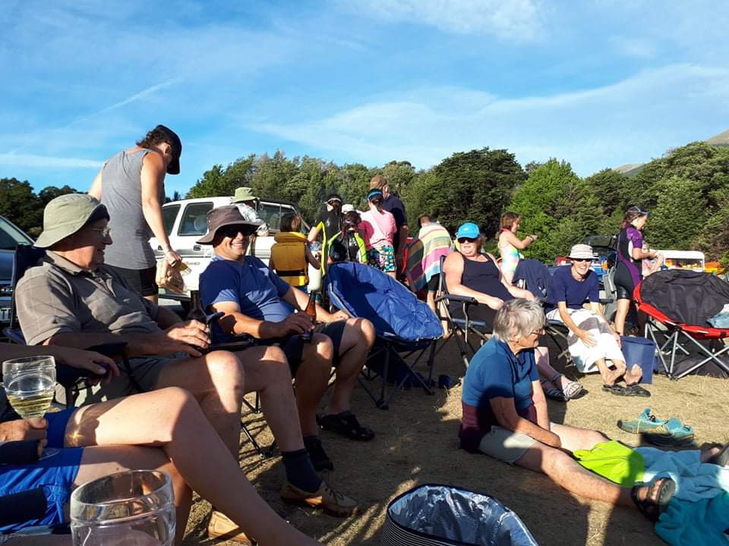
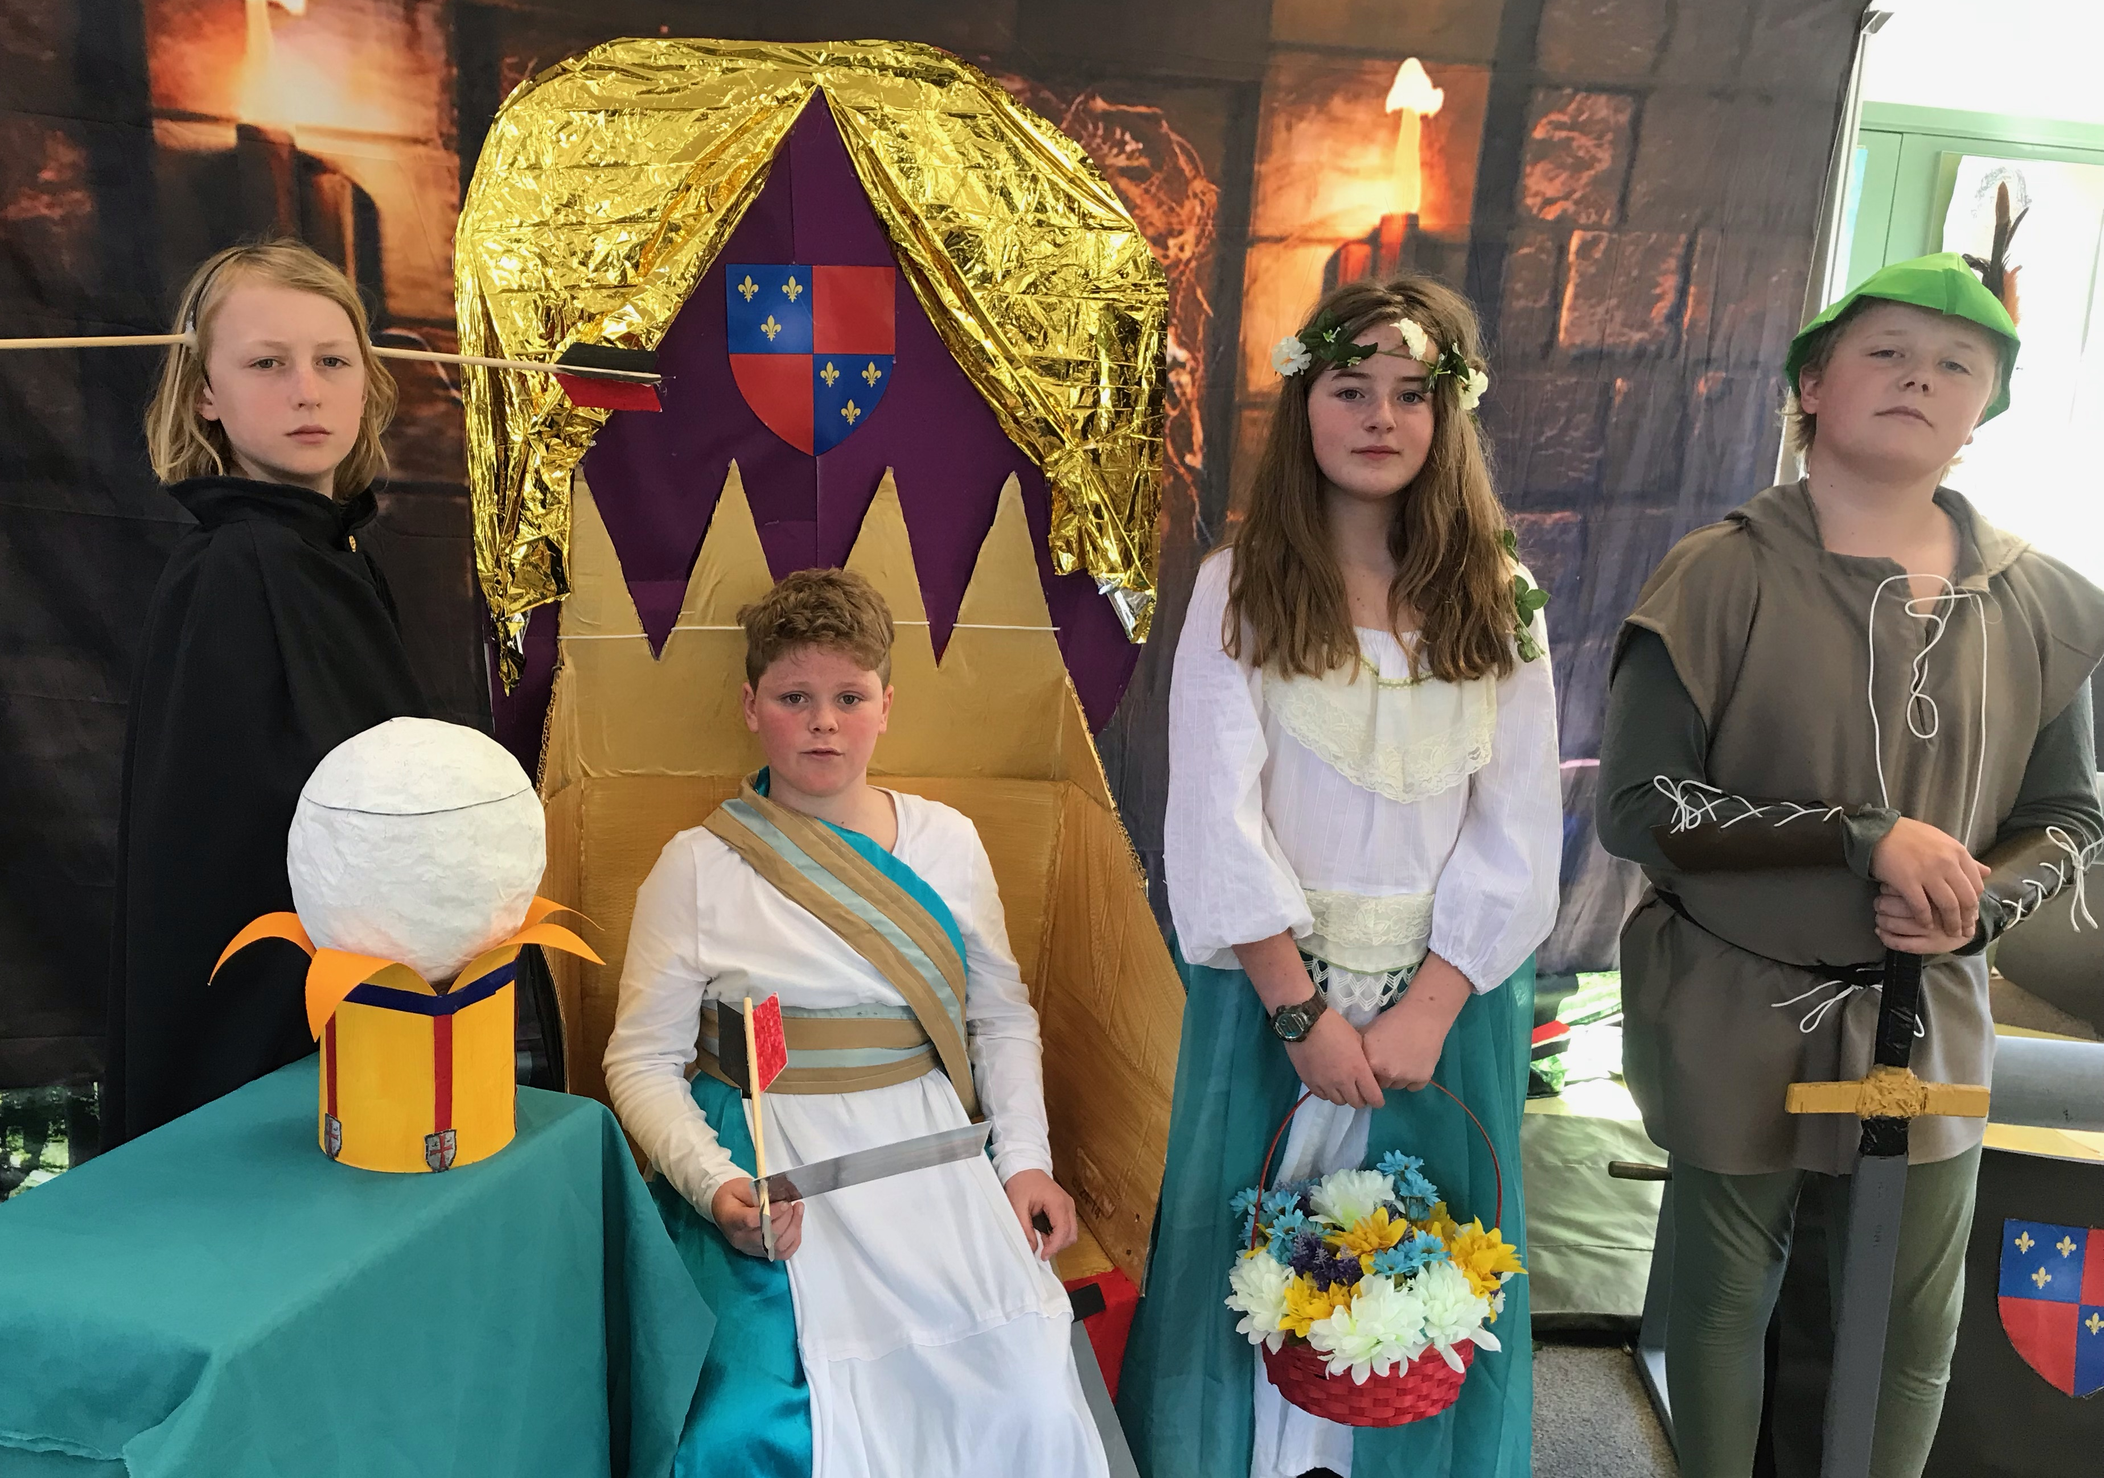
Strategic Plan
2022 - 2025
Strategic Goals |  | 2022 | 2023 | 2024 | 2025
Students’ Learning | Improve outcomes for all akonga, particularly those with special needs and low achievement. | Continue to develop Maths programme with PLD provider.  Continue to develop Local Curriculum, with a particular focus on NZ Histories. | Review Maths Programme efficacy.  Literacy – Reading.  Health and PE consultation.  Implement Histories Curriculum. | Review Literacy – Reading.  Literacy – Writing.  STEAM programme development and links to integrated curriculum. | Review STEAM programme.  Review Maths programme.  Health and PE consultation.
Student Engagement and transition | Ensure local curriculum meets needs of all akonga.  Engage with colleges so Year 8 students have a successful transition. | Review Integrated Cycle 3.  Connect with Colleges to assist with understanding expectations. | Review Integrated Cycle 1.  Embed Local curriculum.  Review curriculum based on College understandings. | Review Integrated Cycle 2.  Review community Consultation systems. | Review Integrated Cycle 3.
Finance and Property | Operate within operations Grant.  Upgrade learning spaces and beautify environment. | Furnish and equip STEAM room.  Engage with MOE for Heating and Lighting Upgrade.  Pool changing rooms.  Paint Library. | Review finance to enable staffing to be kept at 2.0FTTE.  Adventure Playground bark.  Construct 1st Aid room. | Resurface carpark.  Investigate replacement of Senior fort  Modify pool fence to enable easy access for emergency services. | Replace Senior fort  Resurface Tennis court.
Health and Safety | Ensure staff have 1st Aid capability.  Review and minimise risks. | Renew 6401/02.  Replace some playground equipment from 2021 review. | Renew 6401/02.  Re-bark Adventure playground. | Renew 6401/02.  Renew sand in sandpit.
Personnel | Develop Professional Growth cycles.  Ensure staff have capability to meet Student Learning goals. | Engage with NZEI and NZSTA re: Staff changes. | Science/Technology PLD.  360 Review of Appraisal/Professional Growth Cycle systems. | Review PLD for the next 4 years based on known student learning needs.  Embed Science/Technology PLD.
Community Engagement | Sustainable involvement between school and community members. | Community involvement in Tuakana-Teina.  Children have work displayed around the community. | Develop a standard format for school section in the local newsletter. | Review engagement.

Baseline Data or School Context
Students’ Learning
% of given population. i.e.: Total = 24, NZE = 19, Māori = 3, Other = 2, Female = 14, Male = 10

Ethnicity |  | Gender
Other | 9% | Female | 58%
Māori | 12% | Male | 42%
NZE | 79%

Maths
Above
Total | 8 | 33%
NZE | 7 | 36%
Māori | 1 | 33%
Female | 4 | 28%
Male | 4 | 40%
At
Total | 12 | 50%
NZE | 9 | 47%
Māori | 1 | 33%
Female | 8 | 57%
Male | 4 | 40%
Below
Total | 3 | 12%
NZE | 3 | 16%
Female | 1 | 7%
Male | 1 | 10%
Well Below
Total | 1 | 4%
Māori | 1 | 33%
Female | 1 | 7%
Reading
Above
Total | 11 | 45%
NZE | 6 | 32%
Female | 2 | 14%
Male | 5 | 50%
At
Total | 10 | 42%
NZE | 6 | 32%
Māori | 2 | 67%
Female | 6 | 43%
Male | 4 | 40%
Below
Total | 2 | 8%
NZE | 2 | 11%
Well below
Total | 1 | 4%
Māori | 1 | 33%
Female | 1 | 7%

Writing
Above
Total | 10 | 42%
NZE | 10 | 53%
Female | 6 | 43%
Male | 4 | 40%
At
Total | 11 | 46%
NZE | 7 | 37%
Māori | 2 | 66%
Female | 7 | 37%
Male | 4 | 40%
Below
All | 2 | 8%
NZE | 2 | 10%
Male | 2 | 20%
Well Below
Total | 1 | 8%
NZE | 0 | 0%
Māori | 1 | 33%
Female | 1 | 7%

Student Engagement | Average attendance for 2021 has been 96.1% including 5.9% justified absence. This compares very favourably with past years. Data is slightly skewed by Covid. Parents have been very proactive in keeping children home if they have a cough or cold.  A shift to more student centric learning continues to increase engagement.  Students have had significant input into their learning activities in 2021. The School Production, Robin and the Sherwood Hoodies, was an example of high engagement especially as initial rehearsals were online during lockdown.  Students have been involved in surveys to identify features that make our school unique as the Board reviews it’s vision statement and values.
School Organisation and Structures | Staffing was been stable over terms 1 – 3 2021. The loss of one teacher on medical leave in Term 4 created some difficulties.  In Term 4 two members of the Board resigned as a consequence of personal COVID-19 ethical considerations. This has caused some governance disruptions. At the same time the Staff representative resigned her role.  It is expected that the school roll will be between 17 and 20 students in 2022. This roll drop will impact staffing for 2022 but the Board are committed to keeping staffing at a minimum of 2 teachers for the next two years.  The trial local curriculum document which was developed in 2020/21 continues to be refined. The addition of the Histories Curriculum in 2022 will impact this.  The focus on developing a local curriculum for Maths in 2021 has highlighted the importance of knowledge when developing mathematical skills and strategies. Data suggests that our new approach is having a positive outcome.  The Board commenced a review of the School Values and consulted on the Health Curriculum. The values review has been delayed due to disruptions of Board structure.  A rebuild of the PE/Caretaker shed and the development of a dedicated STEAM during 2021 space will create some excellent opportunities for students in 2022.
Review of Charter and Consultation | The Board continued the process of reviewing the Lake Rotoiti School Values and developing a Learner Profile. Consultation commenced in 2021 and was severely curtailed by COVID and Board resignations. There was a strong degree of frustration in the Board as it was perceived that COVID was distracting the Board from its core business.  2022 Timeline:  February – Charter and AOV reviewed and ratified by BOT.  Consultation on Health and PE curriculum.  March – Charter submitted to MOE and shared on the School website.  Parents invited to make appointments for initial conferences.  April – Initial conferences where requested.  June – Mid-Year reports and conferences.  July – Mid-year achievement target reports (Reading, Writing, Maths) to Board including attendance,  behaviour and other curriculum reports.  November – 2023 targets drafted. Analysis of Variance for 2022 prepared and shared with Board. End of year  reports prepared for parents. Charter and Strategic reviewed by Board.

Strategic Section

Strategic Goals |  | Core Strategies for Achieving Goals  2022 - 2025
Students’ Learning | Improve outcomes for all akonga, particularly those with special needs and low achievement. | Review internal data and systems.  Engage with external providers for learning support and PLD.  Engage with Community regarding changes or new developments.
Student Engagement | Ensure local curriculum meets needs of all akonga. | Engage with PLD providers. (CORE-Ed)  Review School Values (Board)  Develop a Student Profile.  Involve students in the development of School Values, Local Curriculum and Student Profile.  Work with PLD provider to develop Histories curriculum.  Develop languages programme that reflects our community.  Continue to develop a Maths document that challenges and accelerates learning:  - A coherent pathway for teaching and learning (including student voice)  - A programme that responds effectively to needs, aspirations and experiences of akonga.  - A document of teacher knowledge of effective pedagogy and strategies.
Finance and Property | Operate within Operations Grant.  Upgrade learning spaces and beautify environment. | Ensure staffing remains at 2FTTE or greater. Fundraising may be required.  Complete STEAM room upgrade, repaint exterior of Library and Junior room, mitigate Library risks, pool changing sheds, adventure playground.
Health and Safety | Ensure staff have 1st Aid capability.  Review and minimise risks. | Bi-annual 1st aid updates and new staff. New sick bay with equipment and storage.  School maintenance register.  Consult on implementation of Health and PE Programmes (2023).
Personnel | Develop professional Growth cycles  Staff capability to meet student learning goals | Work with NZEI/Teaching Council to develop Professional Growth Cycles for 2022.  Continue internal research regarding best practice in Mathematics and developing a LRS Maths Programme.
Community Engagement | Increase involvement between school and community members. | Engagement with community members to create links between school and community. Children involved in community events, community asked to support school activities (e.g.: Tuakana-Teina.)

Annual School Improvement Plan 2022 – SUMMARY
Domain | Strategic Goal | Target | Short Report
Students’ Learning | Improve outcomes for all akonga, particularly those with special needs and low achievement. | Reading: Challenge all students, particularly those below expectations, to accelerate their learning.
 |  | Writing: Challenge all students, particularly those below expectations, to accelerate their learning.
 |  | Maths: Challenge all students, particularly those below expectations, to accelerate their learning.
Student Engagement | Ensure the local curriculum meets needs of all akonga. | Develop an aspirational Year 8 Pupil Profile.  Develop a Curriculum Programme that reflects the special character of Lake Rotoiti.
School Organisation and Structures | Upgrade learning spaces and beautify environment.  Review Values | Complete review, consultation and rewrite of the School Values.  Paint Library and Junior Room.

Reading
Strategic Goal:  Improve outcomes for all akonga, particularly those with special needs and low achievement. |  | Annual Target:  Challenge all students, particularly those below expectations, to accelerate their learning.
Baseline data
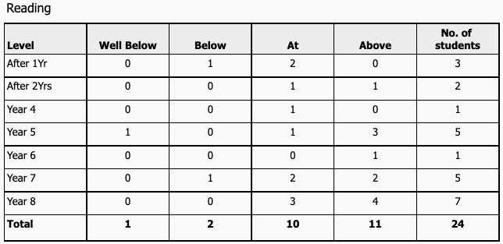
The data shows that we are already achieving our target. One child that is achieving below expectation has been identified as possibly having a diagnosable learning condition. This Child will need to wait another 2 years before receiving an intervention. There is also a child who continues to receive extra support through RTLB to assist accelerated learning. In order to achieve this goal then, we will need to accelerate the learning of at least two students.
One child has been identified as being significantly above expectations and will require a tailored programme in 2022.
Key Improvement Strategies
When | What | Who | Indicators of Progress
Term One | RTLB will be engaged and support will be in place.  Teacher Aide support engaged and programmes in place.  Targeted programmes for other learners will be in place. | Mike, LSC, RTLB | By the end of Term One RTLB will have completed assessment and support will be in place.  Evidence of planning and programmes will be available.
Term Two | Assessment of effectiveness of programmes.  Application for continued support. | Mike, RTLB, LSC | By the end of Term Two regular assessment will show progress.  Application for continued support will be completed if necessary.
Monitoring
Mid-year and End of Year reporting to Board.
Term by term monitoring based on School Assessment procedures.
Resourcing
RTLB support.
ICS funded Teacher Aide.

Writing
Strategic Goal:  Improve outcomes for all akonga, particularly those with special needs and low achievement. |  | Annual Goal  Challenge all students, particularly those below expectations, to accelerate their learning.
Baseline data and Annual Target
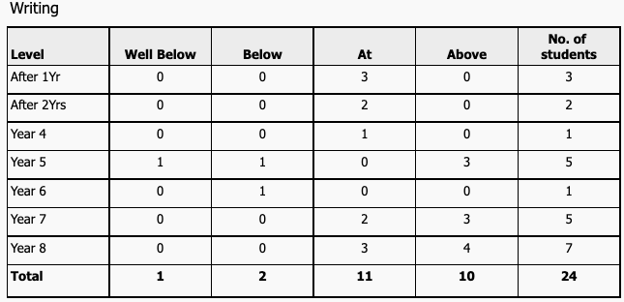
This data set identifies a group of students in the senior area of the school. One low achieving student in this data set is an enrolment from 2020 who has made significant progress and is not far from achieving to expectations. With continued focus it is likely that by the end of 2022, there will only be one child remaining in the lower cohort.
Key Improvement Strategies
When  Term one | What  Deliberate, targeted acts of teaching based on LLP and other data. | Who  Mike Allen | Indicators of Progress  By the end of Term one assessment will be complete and support will be in in place.  Evidence of planning and programmes will be available.  Students will be able to articulate their learning targets.
Term two | Assessment of effectiveness of programmes. | Mike Allen | By the end of Term two regular assessment will show progress.  Application for continued support will be completed if necessary.
Monitoring
Mid-year and End of Year reporting to Board.
Term by term monitoring based on School Assessment procedures.
Resourcing
Nil

Maths
Strategic Goal:  Improve outcomes for all akonga, particularly those with special needs and low achievement. |  | Annual Target:  Challenge all students, particularly those below expectations, to accelerate their learning.
Baseline data:
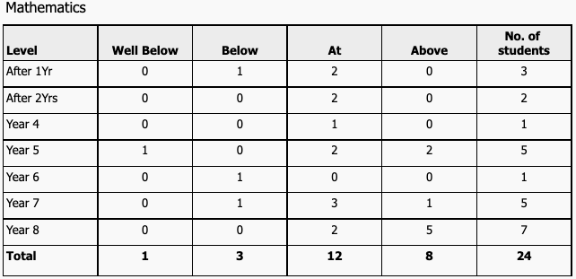
Four children are identified as below expectations. Two of these are new enrolments in Term 4. A focus on basic knowledge has made a significant impact on achievement over 2021 and will continue into 2022.
One child has been identified as being significantly above expectations and will receive a tailored programme.
One child will continue to receive Teacher Aide support through ICS.
Key Improvement Strategies
When | What (examples) | Who | Indicators of Progress
Term 1 | Initial programme ideas for Term 1 and 2 will be mapped. | Mike, TBA | By the end of term one an initial programme will be mapped out.
Term 2 | Preliminary data will be available to show effectiveness of Term 1/2 teaching.  Term 3 and 4 programmes will be mapped. | Mike TBA | Reports will have been provided to parents and the Board showing learning progress.
Term 4 | Terms 3/4 data will be available.  Reports to Board and parents will be provided.  EOY achievement data will inform 2023 actions. | Mike, TBA | By the end of term four, learners will have progressed within their expected level or accelerated to or above expectations.
Monitoring:
Mid-year and End of Year reporting to Board.
Term by term monitoring based on School Assessment procedures.
Resourcing:
Purchase of relevant student texts and equipment.
Purchase of research texts for staff.

Analysis of Variance
2020/2021

Strategic Goals 2021

Goal 1:
Improve outcomes for all akonga, particularly those with special needs and low achievement.

Evaluation
Students that require it have had a personalised programme developed through the Learning Support Coordinator (LSC) and Teacher Aide. Providers acknowledge that our students receive targeted learning as a consequence of small class sizes and that progress was, in most cases, accelerated. Data shows that we have a very high level of achievement in core curriculum.

Our redeveloped maths programme with a strong focus on basic facts and knowledge has been successful. Students are beginning to apply this knowledge instinctively as a part of the strategy and skills teaching. The programme needs continued development and a clear progression of learning.

Goal 2:
Ensure the local curriculum meets needs of all akonga.

Evaluation
This goal continues to be developed. The Histories Curriculum will become a part of the programme in 2022/23. There also needs to be an increased te reo and tikanga function. Redeveloped Values statements will also have an impact.
Covid-19 lockdowns slowed development in 2021.
Consideration for a second language that reflects our community needs to be included in the Local Curriculum.

Goal 3:
Upgrade learning spaces and beautify environment.
Review Values

Evaluation
A significant programme of planting was undertaken. 350 trees were planted as part of a community initiative.
The redevelopment of a classroom block into a STEAM room has progressed slowly and the building has been repainted. Part of this build was a new toilet area and secure cleaner’s cupboard. It also has a covered veranda which promises to be a great extended learning space.
A new PE shed and Caretakers shed have solved a serious storage shortage and mitigated a health risk due to a rodent infestation.
The development of a new Values statement has been delayed due to COVID, staffing, and Board issues.

