

Deadline for next issue:   
Friday 6 June 2019

Please send your newsletter items to: rotoitinews@gmail.com

This newsletter was produced with the help of the Rotoiti District Community Council, Department of Conservation and Mark & Tania Gill.

You can download a copy of previous newsletters from www.lakerotoiti.school.nz/newsletters

**Coming up**

At the Community Hall

**Monday**

**Badminton** **7pm**. $3.00

Contact Ed or Nicky Shaw

521 1106

**Monday, Wednesday, Friday**

**Circuit Training Exercise Group**

10.00 am. All welcome.

Gold coin koha

Contact Gael 027 2804 078

**Tuesday**

Seido-Karate 6pm.

---------------------------------

**Village Trapping Group** - Pip Berkett 521 1130 or Julie Robilliard 5211874

Sundays 10.30 am

**Lake Rotoiti Chapel**

services are run by locals and non-denominational. Everyone welcome.

Sunday – 3pm

**The Hub**

**Christian Worship Group** Contact Nigel or Sarah Calder 027 4413776

**Yoga and Massage** at Alpine Lodge

Phone Ashton 022 525 7871

**School Board Meeting**

Lake Rotoiti School

25th June 2019

**Alpine Flash Mob:**

Last Monday of each month at Wendy Bolitho. 19 Toutowai Place or

Contact Jan 521 1999

**Note**: regular notices about fitness related activities are listed in a separate box within the Newsletter.

Photo credits:

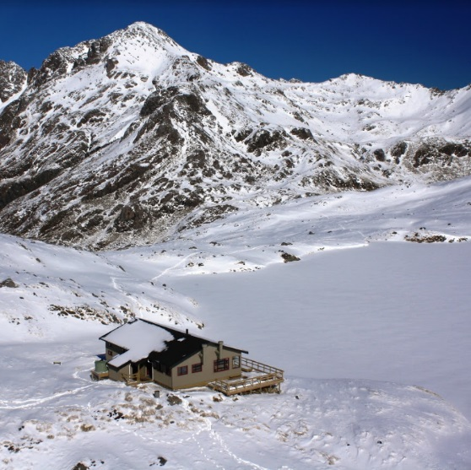

## Lake Rotoiti School News

**Happenings at our kura (school)**

Tēnā koutou katoa,

Or term started with our first ever mihi whakatau to welcome Alison to our Kura/School.  Parents and community joined together while the Kura/school welcomed Alison and the manuhiri.  The support shown by the tangata whenua (people from the lake area) was something to be proud of.

Term two is proving to be a very settled term - there is a heavy focus on literacy and mathematics. To support math learning, we are planning tamariki (children) to join up with community business, in an effort to gain a deeper appreciation of where we use ‘math’ in a day to day setting.  If you have a community business and would like to support us in celebrating Maths Big Day out, please contact Sue - details below.

Last week we headed into Nelson and listened to the Royal New Zealand Air Force Band.  The performance was jaw dropping!! The tamariki clapped, stamped, sang and cheered to a variety of rhythms.  We left the concert with George Ezra’s song ‘Shotgun’ playing in our minds. Thank you Fiona - for being so patient with the tamariki on the way home in the bus!!!

**Farewells and welcomes and congratulations**

We would like to say farewell and thanks to Stephanie for helping our kura in Term 1. We have appreciated your support in Piwakawaka, with

duties, plus assisting our wonderful, respectful learners/ākonga. Stephanie your patience, calm presence and warmth will be missed. Please enjoy your time with whānau.

Also thank you to Jan, who has kept the library fires warm for several years.  Jan is taking on the challenge of a ‘Wall to Wall’ gallery artists co-op in Nelson.  This certainly sounds intriguing and we look forward to learning about your adventures Jan.  We will be having a shared kai, farewell morning tea for Jan on the 7th June 10.30 at the library.  Please join us.

I would like to extend a very warm welcome to Dotty, our new teacher assistant.  Dotty will also be helping with the library.

Congratulations to Dan, who attended his capping in Dunedin last week.  This certainly is an exciting event to be part of. The Street Parade and The Master of Ceremonies korero (speech) are not to be missed.

**Help required**

We are after firewood for our library and Ngā Manu O Tane – multi-purpose room.  If you are able to donate any firewood please contact Sue. Details below.

We are also wanting to contact any keen gardeners. We have a garden kaitiaki (guardians) group, who would like to be doing more landscaping around the kura.  If you are available and keen to help us with advice, plant options, etc - we would love to hear from you. Again - details below.

**Te Reo:**

I am presently gaining ‘expressions of interest’ on anyone who wishes to learn basic Te Reo, such as greetings, sentences, tikanga. Please let Sue know.

**Last but not least - A big Thank you**

A shout out to the wonderful parents who have helped our kura this term.  We certainly can’t do all this amazing learning and have adventures without your support.  So ngā mihi nui. A big thank you.

Thank you also to the wonderful people from the community who drop in and say hello to us during the term.  We appreciate your visits and conversations. The door is always open for you to share ideas, skills or talents with all of us learners at Lake Rotoiti School.

Contact details   [principal@lakerotoiti.school.nz](mailto:principal@lakerotoiti.school.nz)   03 521 1830

**St Arnaud Alpine Store Winter Hours**

Monday to Saturday  from 8.00am to 5.30pm

Sunday from  8.30am to 5.30pm

Fish N Chip shop is closed and will reopen on Friday 5th July 2019



**Cat Census**

DOC and Friends of Rotoiti run feral cat-trapping programmes in the wider St Arnaud area.

DOC targets cats on public conservation land only, and run their programme in autumn/early winter.  DOC trapped Teetotal Recreation Area again in April this year. Friends of Rotoiti co-ordinate a trapping programme with private landowners in more rural areas. This programme runs most of the year.

DOC run a census of domestic cats each year. We provide details of your cat to the Friends of Rotoiti (FOR) cat trapping programme so trappers can check if cats caught in a live capture cage trap are pets. Feral cats are the target of the trapping programme.

A cat’s behaviour in the cage trap is not always a good indicator of whether it is domestic or feral. Neither DOC nor FOR check microchips of cats caught in live capture traps.

The cats currently recorded in the census are: Anderson, Ghost, Smooch, Tiger, Moppet, Little Blue, McKenzie and Charlie.

If there are any changes to this list or if  you would like your cat’s details to be included in the cat census, send your name, address, phone numbers, cat’s name, a recent photo, and any distinguishing marks to Tracey Grose, Senior Community Ranger (tgrose@doc.govt.nz or 03 521 1806) – by Friday 7 June.  Thank you.

`````````````````````````````````````````

**STUDIO TO LET**

Self contained studio in village to rent either short or long term. Suitable one person.  Contact Karen to discuss availability on 021 066 7000.

**Rotoiti District Community Council Meeting**

Just a friendly reminder that the next Rotoiti District Community Council meeting will be held on **Wednesday** 26 June, starting at 7.15pm.  The meeting will be held at the DOC meeting room.

If you were not aware, the change of day of the week is to accommodate the Executive Committee members who work full time. Weekends are time for family.

This day of the week also allows external parties to attend for example, Mayor of TDC or Manager of NZTA.

If you have any topics you would like on the agenda, please email them to rotoititcommunitycouncil@gmail.com before 20 June.

This meeting is open to anyone who would like to attend.

Look forward to seeing you on Wednesday 26 June.

**Rotoiti District Community Council Minutes:**

At the Rotoiti District Community Council meeting held on Friday 3 May, the following topics were discussed:

·         Tasman District Council advised that the Newsline had not been delivered for a few months.

·         Competition for design of signs for reducing vehicle speed within the village 30km/hr zones

·         Approach NZTA for funding and construction of a “footpath” alongside SH63 for cyclists and Te Araroa walkers.

·         Request to Tasman District Council following consultation on new footpath priorities for the region requesting a footpath from Lodge Road to Kerr Bay Road

·         Subcommittee set up to discuss and action a potential fire break on the peninsula and fire smart within the village

·         Tasman District Council requested to remove the portaloos on the Main Road now that the toilet block is open

·         Tasman District Council advise that rabbits are not a pest within the Tasman Regional Pest Management Plan. RHDV1 K5 rabbit virus is being tested on a property close to the village.  Traps are available from Council – if interested contact Lindsay Barber on 03 543 8400

·         Request NZTA to recalibrate the speed sign at the north of the village following its replacement

·         Request Fulton Hogan to reinstate and add additional arrows on the Main Road outside the store, toilet block and Kerr Bay Road to ensure drivers return to the left-hand side of the road

·         DOC advised that the Hukere Bridge is about to be removed for the winter months so access to Angelus is via Speargrass and Robert Ridge routes only

·         Upgrade of Kerr Bay campground facilities are due to begin in September with major changes to the toilets/showers, install a new handicap facility and upgrade of the hot water facilities to be available all year round

·         Update from Tasman District Council following the Pigeon Valley Fire event had a considerable impact on Council staff, workload and Council’s work programme.  The Consents Team are short staffed therefore high workload with longer timeframes. The Pest Management Strategy was publicly notified, with no appeals.

·         Update on progress with the Rotoiti Lodge renovations. There are seven phases to the project including replacing the kitchen facilities, new/larger deck and double glazing throughout. Once the project is complete there will be a re-launch.

·         Next meeting to be held on Wednesday 26 June at 7.15pm

**Nelson Tasman Community Speed Survey**

Central government has placed a focus on reducing serious injuries and deaths associated with crashes on our roads, not only by investing in road safety improvements, but also ensuring ‘safe and appropriate’ travel speeds.

Of course the ‘safe and appropriate’ speed will vary for different types of roads, depending on their main use and characteristics.

Both Nelson City and Tasman District are starting work on reviewing the current speed limits. For speed limits to be effective, they need to be underpinned by community support and understanding.

That’s why we want to hear from you.

Please take the time to complete this online survey. It’s your chance to tell us what speed limits you think are safe and appropriate on the different types of roads we have across our region. Share with your family, community groups and neighbours.

**Tell us what you think**

<https://www.tasman.govt.nz/my-council/public-consultation/current-consultations/nelson-tasman-community-speed-limit-survey-tell-us-what-you-think/>

This feedback will help us as we review our speed limits. There will be a formal consultation process to follow if speed limit changes are proposed for specific roads.

**Closing date: Friday 14 June 2019**

**House available for rent**

4 bedroom unfurnished house on quiet street in the village - available now. Log burner, 2 separate lounges, kitchen and dining combined, separate toilet, and single garage. Part of the section is fully fenced. Bond required.

$275 per week

Please contact Jo Joice on 027 571 1497

**Civil Defence Group needs your help**

The**local** **Fire and Emergency/Civil Defence group** is currently looking at what resources may be in the village and can be used in an emergency situation.

Do you have skills which could share if required?

These may include medical qualifications or experience, trade skills, languages other than English etc.

At this stage we’d just like to know what’s available in the way of local talent and who we can call on to volunteer help if required.  This is a small community but often

has lots of visitors staying who we may need to help with.

If you are willing to have your info listed please contact Jan Thomson with your details. janthomsonart@gmail.com  or 03 5211999. **All information will be confidential to the emergency group.**

**Road Safety Funding**

Tasman District Council have road safety funding available for young drivers in our region.  This could go towards driver assessments (so they go for an assessment with a professional driver to get some great tips and advice and feel more confident on the road) , and/or for learner licence courses for a group that want some help with learning the road code.

This is aimed at young drivers and is open to anyone that is struggling to get through the road code, or needs confidence with driving as it can affect people’s employment and general quality of life.

If you know of anyone that may benefit from this please get in touch with Megan Bell of Tasman District Council, Technical Officer - Transportation (Road Safety Liaison) phone 03 543 8551 or email megan.bell@tasman.govt.nz. Transportation costs may also be available to assist to get to the course.

**CARDS GALORE**

**Looking for cards!!**

I have a very large collection of quality greeting cards for sale which I have imported from the UK.

Priced from $2.00 each.

Contact Tracy Younger on **0278927630** or  [**tracyyounger0603@gmail.com**](mailto:tracyyounger0603@gmail.com)**.**

Check out my website – [**www.tycards.online**](http://www.tycards.online)







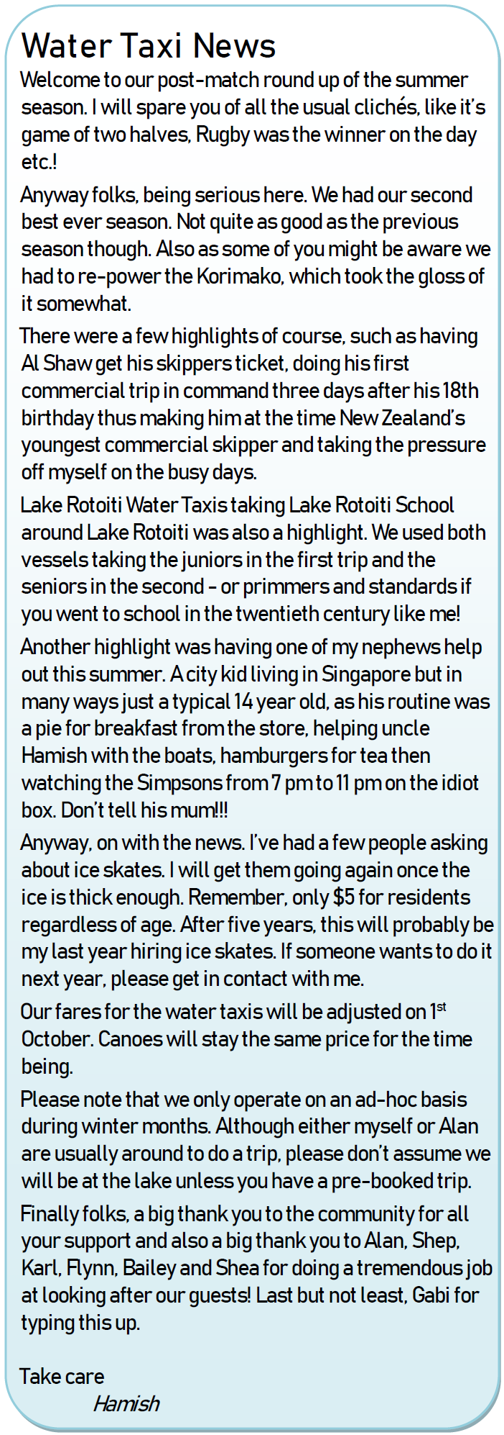

[](https://www.google.com/url?sa=i&source=images&cd=&cad=rja&uact=8&ved=2ahUKEwiNjNCAzrHbAhVMJ5QKHc0_A74QjRx6BAgBEAU&url=https://theactivemummyaus.com/&psig=AOvVaw3F7Xlk4q_nDU5SIh_em2vc&ust=1527913046315346)

BE GET STAY

Regular activities in and around St Arnaud

**Badminton**

Mondays 7pm

Community Hall

$3 per person to cover hall and shuttle cocks.

Ed 5211106

**“Circuit Breakers”** exercise group

Monday, Wednesday, Fridays 10 am,

Community Hall

All welcome, gold coin donation

Gael 0272804078,

**Seido-Karate**

Community Hall

Tuesdays 6pm - kids & beginners

Thursdays 6 pm – General Class

Toni Calman 03 5390681. Gold coin donation

**Yoga – all levels**

Alpine Yoga and massage

Ashton 022 525 7871

**Tuesday trek** to Parachute Rocks

12th June, Pip 5211130





Contributing to the newsletter

Please send your contributions in the following formats:

* Advertising and notices sized to fit the newsletter columns. Accepted formats: MSWord, PDF or JPG.
* Full page ads incur a fee - $30 (b&w) or $70 (colour). This is a contribution towards photocopying costs. Please pay at the Rotoiti/Nelson Lakes Visitor Centre.
* Articles: plain text submitted in MS Word format, or in the body of an email.
* Photos: JPG files up to 5MB, attached to an email (not embedded in text).

Contact: [rotoitinews@gmail.com](mailto:rotoitinews@gmail.com)

