Kids address worries with conceptual art

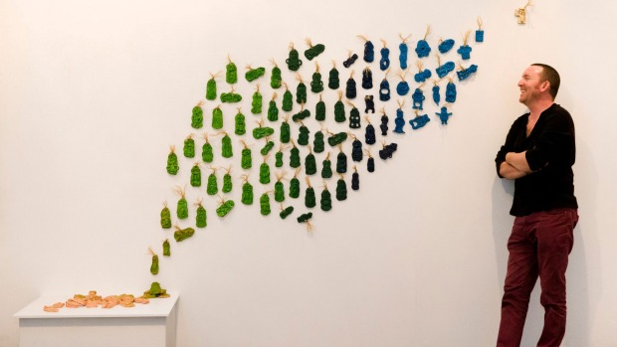
Marion van Dijk
Lake Rotoiti School principal Giles Panting in front of a tiki display created by his students at the No Fixed Plans exhibition at Refinery Artspace.

Two young students from Lake Rotoiti School have taken their dislike for vegetables to the next level by creating an artwork as part of the school's exhibition in the Refinery Artspace in Nelson.
The exhibition titled 'No Fixed Plan…….a Journey into Philosophy and Art' is a culmination of the school's 33 students conveying their thoughts in conceptual art. The result was nothing short of inspiring, said principal Giles Panting.
"The artworks have been done extremely well. Conceptual art is hard but [the students] seem to have a great understanding of it," he said.
The art works were made by students aged from 5 to 13 years as part of the school's philosophy programme.
The philosophy programme is designed to teach children how to think rather than tell them what to think, Panting said.
"The children's understanding of conceptual art could possibly exceed an adult's - [children] are so open-minded and are happy to run with ideas," he said.
The artworks were inspired by this philosophy, with children coming up with an idea and conveying it for the exhibition. Many artworks conveyed children's worries and dislikes, including a common grievance among children - vegetables.
A year 6 and a year 8 student teamed together to create the anti-vegetable artwork - a mannequin covered with words to describe their dislike and a plate of vegetables sitting in front of the model.
Another student conveyed the idea of worry, which was shown through a jar of stones, with some spilling out to show the effect of feeling overwhelmed with the emotion.
"The worries are shown on stones because worries are heavy," Panting said.
He said the most difficult part of the four to five week project for the students was coming up with an idea, but once they had secured this, minimal guidance was needed.
"The kids wanted to give an experience [through their artworks] so they made some interactive," he said.
The exhibition includes a whole-school artwork which depicts 110 clay tiki made by the children. The work is titled 'I Can't Go Back to Yesterday?' and was designed with the question of who owns the idea of an art work in the minds of the children, Panting said.
"We get a full range of answers. Some say they all own the idea because they made it and [some children] say it was the artist who came up with the idea," he said.
"The first tiki made by the children were very traditional, but by the time they were making their third or fourth, the tiki were evolving into something quite different. The tiki are displayed to reflect this process and the work has almost become a metaphor for the identity and change."
The exhibition will have an official opening event on June 23 with the students, and will run until July 3.
- Stuff

