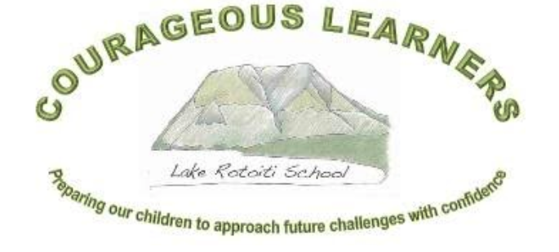

School Charter, Analysis of Variance, Strategic and Annual Plan
Lake Rotoiti School (3199)
2021 - 2024
Principals’ endorsement:
Board of Trustees’ endorsement:
Submission date to Ministry of Education:

Lake Rotoiti School
Our School

Lake Rotoiti School is a small two teacher school (26 children in 2020) situated in the Nelson Lakes National Park. The school draws learners from a range of farming, Department of Conservation, hospitality and entrepreneurial backgrounds. As a result of Covid-19 some families have moved into the area and run businesses remotely.

Mt Robert (Porangahau) is a notable feature of the landscape and is part of our Logo. At the base of the mountain is Lake Rotoiti. There are many recreational and learning opportunities to be found in the area: tramping and walking, trapping, hunting, fishing, water skiing, skiing, sailing and gliding to name some.

Children are enthusiastic and engaged in their learning through a local curriculum that is constantly being reviewed and improved. They are encouraged to support each other through tuakana-teina activities, Inquiry based learning and formal teaching approaches. Because of our small roll and class sizes, programmes and learning can be tailored to individuals.

Our children are very environmentally aware. We utilise the local environment and the community to assist learning and to engage with our akonga wherever possible. Over the years all of the opportunities listed above have been provided to the children. Significant learning opportunities are undertaken with the support of DOC and a very involved parent community. These have academic, well-being and recreational outcomes.

Lake Rotoiti School has a heated swimming pool. Children learn swimming and water safety from dedicated providers who come to us from Nelson. Children also learn to sail on the pool and transfer this skill to the Lake on Thursday evenings during summer.

Kea Kai is an extremely active group of parents who raise sufficient funds to heavily subsidise our annual School Camp and to subsidise 5-7 ski days at Rainbow ski field every winter for every child. This is our winter sport/PE programme.

Our community is strong, supportive, inclusive and connected. During summer we meet socially at the Lake so the children can play, sail, swim and go biscuiting. It is a wonderful environment for children to grow into connected and well-rounded adults.

Mission, Vision, Values

Mission Statement | Preparing our children to approach future challenges with confidence.
Vision | Courageous Learners.
Values | Honesty and Integrity Inquiry and Curiosity Pride in achievements of self and others  Risk Taking Persistence and Resilience Respect for and Pride in our unique environment
Principles | High Expectations Treaty of Waitangi Cultural Diversity Inclusion  Learning to Learn Community Engagement Coherence Future Focus
Māori Dimensions and Cultural Diversity | Local history and tangata whenua (Ngati Apa). Te reo and tikanga as part of regular instruction  Dedicated kapahaka and waiata opportunities. Inclusion of all akonga regardless of gender,  ethnicity or ability.

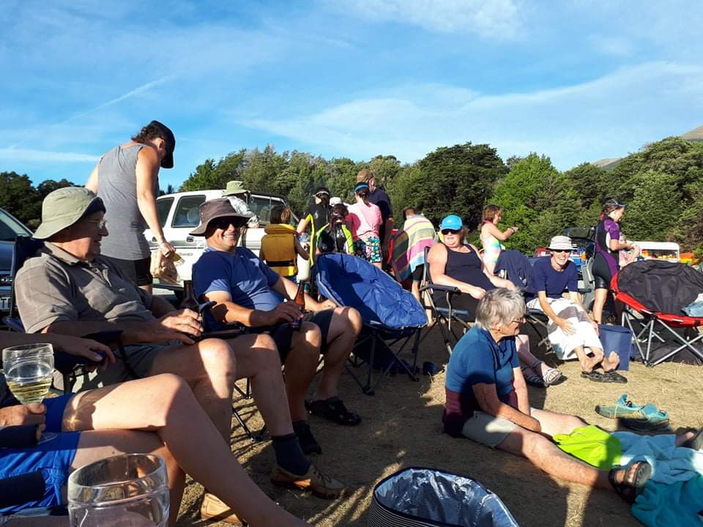
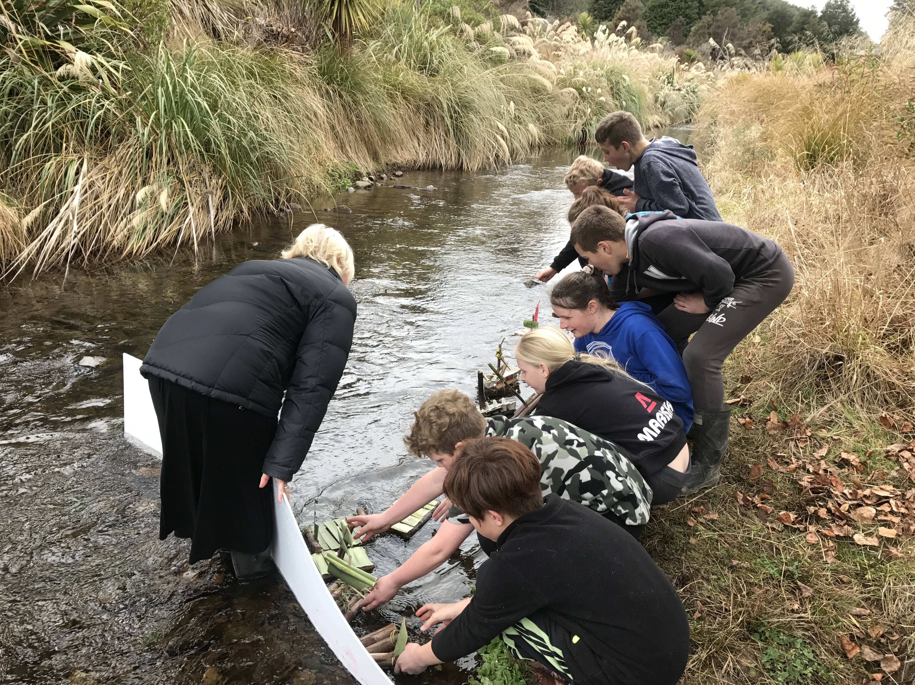
Strategic Plan
2021 - 2024
Strategic Goals |  | 2021 | 2022 | 2023 | 2024
Students’ Learning | Improve outcomes for all akonga, particularly those with special needs and low achievement. | Maths programme development.  Health and PE consultation. | Review of Maths programme.  Literacy – Reading. | Review Literacy – Reading.  STEAM programme development and links to integrated curriculum.  Health and PE consultation. | Review STEAM programme.  Literacy – Writing.
Student Engagement and transition | Ensure local curriculum meets needs of all akonga.  Engage with colleges so Year 8 students have a successful transition. | Engage with PLD providers to review local curriculum.  Review Integrated Cycle 2.  Establish systems to assist with Roll predictions. | Local Curriculum PLD.  Review Integrated Cycle 3.  Connect with Colleges to assist with understanding expectations. | Review Integrated Cycle 1.  Embed Local curriculum.  Review curriculum based on College understandings. | Review Integrated Cycle 2.  Review community Consultation systems.
Finance and Property | Operate within operations Grant.  Upgrade learning spaces and beautify environment. | Monitor budget during refurbishment.  STEAM room, PE shed, LSC space, Library Paint, Bund planting. | Complete, furnish and equip STEAM room.  Pool changing rooms.  5YP cycle. | Review finance to enable staffing to be kept at 2.3FTTE.  Adventure Playground bark. | Resurface carpark.
Health and Safety | Ensure staff have 1st Aid capability.  Review and minimise risks. | Renew 6401/02.  Review playground equipment safety. | Renew 6401/02.  Replace some playground equipment from 2021 review. | Renew 6401/02.  Re-bark Adventure playground. | Renew 6401/02.
Personnel | Develop Professional Growth cycles.  Ensure staff have capability to meet Student Learning goals. | Engage with NZEI /Teachers’ Council for guidance.  Engage with PLD providers. | Science/Technology PLD.  Engage with NZEI and NZSTA re: Staff changes. | 360 Review of Appraisal systems.  Embed Science/Technology PLD. | Review PLD for the next 4 years based on known student learning needs.
Community Engagement | Sustainable involvement between school and community members. | Investigate skills and opportunities in the community. Invite discussion. | Community involvement in Tuakana-Teina.  Children have work displayed around the community. | Develop a standard format for school section in the local newsletter. | Review engagement.

Baseline Data or School Context
Students’ Learning

Maths
Above
Total | 7 | 32%
NZE | 7 | 36%
Female | 5 | 35%
Male | 2 | 25%
At
Total | 12 | 55%
Asian | 1 | 100%
Māori | 2 | 100%
NZE | 9 | 47%
Female | 7 | 50%
Male | 5 | 62%
Below
All | 3 | 14%
NZE | 3 | 15%
Female | 2 | 14%
Male | 1 | 12%
Well Below
Total | 0
Reading
Above
Total | 10 | 45%
NZE | 10 | 52%
Female | 7 | 50%
Male | 3 | 37%
At
Total | 11 | 50%
Māori | 2 | 100%
NZE | 9 | 47%
Female | 6 | 42%
Male | 5 | 62%
Below
All | 1 | 5%
Asian | 1 | 100%
Female | 1 | 7%
Male | 0 | 0
Well Below
Total | 0

Writing
Above
Total | 5 | 23%
NZE | 5 | 26%
Female | 4 | 28%
Male | 1 | 12%
At
Total | 11 | 50%
Asian | 1 | 100%
NZE | 10 | 52%
Female | 9 | 64%
Male | 2 | 25%
Below
All | 5 | 23%
Māori | 2 | 100%
NZE | 3 | 15%
Female | 1 | 7%
Male | 4 | 50%
Well Below
Total | 1 | 5%
NZE | 1 | 5%
Female | 0 | 0
Male | 1 | 12%

Ethnicity |  | Gender
Asian | 4% | Female | 63%
Māori | 9% | Male | 36%
NZE | 86%

Student Engagement | 2020 attendance data has been skewed by Covid-19. The average attendance for the year has been 91.8%. At the beginning of the year it was 90% and the previous year was significantly lower. A shift to more student centric learning has increased engagement.  Achievement data from 2019 was not reflected in the data from the beginning of 2020. This has skewed achievement data when compared with 2018/19 data.  Parents and students doubted the accuracy of 2019 learning outcomes and trust in robust data had to be rebuilt by the staff.  Anecdotal evidence indicates that students had little input into their learning voyage in 2019 and with a shift in 2020 to greater voice, there has been greater engagement and small but steady roll growth.  Teachers have made a point of not attending out of hours courses or meetings in order to provide learning stability.
School Organisation and Structures | Staffing has been stable in 2020. There has been significant churn in the past three years. The Board and community want this stability to continue. Roll drop will impact staffing for 2022 and the Board wish to keep 2.3FTTE at their own cost for at least 2 years if this happens.  A new trial curriculum document was developed during Covid-19 lockdown.  The Board have identified the need to review the School Values (pre-2016) and consult on the Health Curriculum.
Review of Charter and Consultation | At the end of 2020 the Board began the process to review the Lake Rotoiti School Values and develop a Learner Profile. They have sought support from NZSTA to go through this process. Full consultation will occur in 2021.  The Strategic Plan was reviewed at the end of 2020.  The Health and PE consultation is due in 2021 and will be carried out in Term 1.  2021 Timeline:  February – Charter and AOV reviewed and ratified by BOT.  Consultation on Health and PE curriculum.  March – Charter submitted to MOE and shared on the School website.  Parents invited to make appointments for initial conferences.  April – Initial conferences where requested.  June – Mid-Year reports and conferences.  July – Mid-year achievement target reports (Reading, Writing, Maths) to Board including attendance,  behaviour and other curriculum reports.  November – 2022 targets drafted. Analysis of Variance for 2021 prepared and shared with Board. End of year  reports prepared for parents. Charter and Strategic reviewed by Board.

Strategic Section

Strategic Goals |  | Core Strategies for Achieving Goals  2021 - 2024
Students’ Learning | Improve outcomes for all akonga, particularly those with special needs and low achievement. | Review internal data and systems.  Engage with external providers for learning support and PLD.  Engage with Community regarding changes or new developments.
Student Engagement | Ensure local curriculum meets needs of all akonga.  Engage with colleges so Year 8 students have a successful transition. | Engage with PLD providers. (CORE-Ed)  Review School Values (Board)  Develop a Student Profile.  Involve students in the development of School Values, Local Curriculum and Student Profile.  Examine data to determine how, and how well, our Maths programme supports our learners.  Develop a Maths Programme that challenges and accelerates learning.  Contact Garin and Marlborough Boys’ to discuss expectations that they have.
Finance and Property | Operate within Operations Grant.  Upgrade learning spaces and beautify environment. | Ensure staffing remains at 2FTTE or greater. Fundraising may be required.  Complete STEAM room upgrade, review 5YPP and 10YPP, repaint exterior, mitigate Library risks, pool changing sheds, bund planting, adventure playground. Replace lawnmower.
Health and Safety | Ensure staff have 1st Aid capability.  Review and minimise risks. | Bi-annual 1st aid updates and new staff. New sick bay with equipment and storage.  School maintenance register.  Consult on implementation of Health and PE Programmes (2021/2023).
Personnel | Develop professional Growth cycles  Staff capability to meet student learning goals | Work with NZEI/Teaching Council to develop Professional Growth Cycles for 2021.  Internal research regarding best practice in Mathematics and developing a LRS Maths Programme.
Community Engagement | Increase involvement between school and community members. | Engagement with community members to create links between school and community. Children involved in community events, community asked to support school activities (e.g.: Tuakana-Teina.)

Annual School Improvement Plan 2021 – SUMMARY
Domain | Strategic Goal | Target | Short Report
Students’ Learning | Improve outcomes for all akonga, particularly those with special needs and low achievement. | Reading: Challenge all students, particularly those below expectations, to accelerate their learning.
 |  | Writing: Challenge all students, particularly those below expectations, to accelerate their learning.
 |  | Maths: Challenge all students, particularly those below expectations, to accelerate their learning.
Student Engagement | Ensure the local curriculum meets needs of all akonga. | Develop an aspirational Year 8 Pupil Profile.  Develop a Curriculum Programme that reflects the special character of Lake Rotoiti. | On-going.  Curriculum Programme is being developed with the support of Nick Major (CORE) and with input from ERO (Shelley Wylie)  Maths continues to be a key focus with the Histories curriculum being thrown on top by the MOE.
School Organisation and Structures | Upgrade learning spaces and beautify environment.  Review Values | Complete 10YPP goals.  Develop new 5YPP.  Complete review, consultation and rewrite of the School Values.  Consult on Health and PE programme. | 10YPP completed. 3YPP developed to bring us into line with other schools and streamline procurement in the future.  Review and consultation complete. Rewrite in progress for 2022.  Consultation completed in July 2021.

Reading
Strategic Goal:  Improve outcomes for all akonga, particularly those with special needs and low achievement. |  | Annual Target:  Challenge all students, particularly those below expectations, to accelerate their learning.
Baseline data
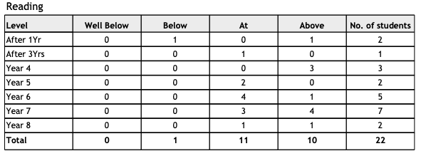
The data shows that we are already achieving our target. However, there are two children not on this data set due to their age, and early indications show that at least one of these children will progress slowly. There is also a child who will be receiving extra support through RTLB to assist accelerated learning. In order to achieve this goal then, we will need to accelerate the learning of at least two students.
One child has been identified as being significantly above expectations and will require a tailored programme.
Key Improvement Strategies
When | What | Who | Indicators of Progress
Term One | RTLB will be engaged and support will be in place.  Teacher Aide support engaged and programmes in place.  Targeted programmes for other learners will be in place. | Alison, RTLB | By the end of Term One RTLB will have completed assessment and support will be in place.  Evidence of planning and programmes will be available.
Term Two | Assessment of effectiveness of programmes.  Application for continued support. | RTLB, Alison | By the end of Term Two regular assessment will show progress.  Application for continued support will be completed if necessary.
Monitoring
Mid-year and End of Year reporting to Board.
Term by term monitoring based on School Assessment procedures.
Resourcing
RTLB support.
ICS funded Teacher Aide.

Writing
Strategic Goal:  Improve outcomes for all akonga, particularly those with special needs and low achievement. |  | Annual Goal  Challenge all students, particularly those below expectations, to accelerate their learning.
Baseline data and Annual Target
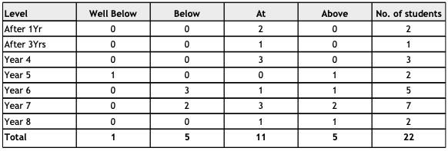
This data set identifies a group of students in the senior area of the school. One low achieving student in this data set is a recent enrolment who is exhibiting characteristics requiring deeper evaluation and potentially extra support. There is one child who does not appear in the data set due to their age, but will appear in the next cohort.
The target of 88% is realistic if we can move a minimum of two students from below or well below.
Key Improvement Strategies
When  Term one | What  Full assessment by RTLB  Deliberate, targeted acts of teaching based on LLP and other data. | Who  RTLB  Mike Allen | Indicators of Progress  By the end of Term one assessment will be complete and support will be in in place.  Evidence of planning and programmes will be available.  Students will be able to articulate their learning targets.
Term two | Assessment of effectiveness of programmes. |  | By the end of Term two regular assessment will show progress.  Application for continued support will be completed if necessary.
Monitoring
Mid-year and End of Year reporting to Board.
Term by term monitoring based on School Assessment procedures.
Resourcing
RTLB support.
Possible ICS application.

Maths
Strategic Goal:  Improve outcomes for all akonga, particularly those with special needs and low achievement. |  | Annual Target:  Challenge all students, particularly those below expectations, to accelerate their learning.
Baseline data:
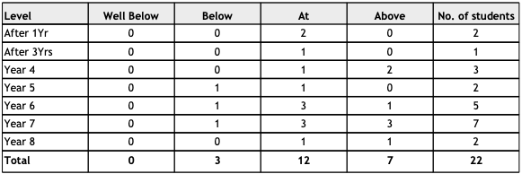
Three children are identified as below expectations. The staff have identified a significant lack of mathematical basic knowledge which has not been addressed through the 2019/20 PLD contract (DMiC).
Two children have been identified as being significantly above expectations and will require a tailored programme.
Children who are already achieving or are in the 31% of high achievers expressed a strong dissatisfaction or disengagement with the programme being used. As a result, in the early stages of 2020 Lake Rotoiti School withdrew from the PLD and elected to change focus. Engagement and achievement have subsequently risen measurably. In order to achieve this target, two children will need to shift from below to at or above expectation.
Key Improvement Strategies
When | What (examples) | Who | Indicators of Progress
Term 1 | Staff will have read relevant research and discussed.  Initial programme ideas for Term 1 and 2 will be mapped. | Mike, Alison | By the end of term one an initial programme will be mapped out and a rationale written.
Term 2 | Preliminary data will be available to show effectiveness of Term 1/2 teaching.  A review of Term 1/2 programme will be complete, including student voice.  Term 3 and 4 programmes will be mapped. | Mike Alison | By the end of term two, teachers will have trialled an initial programme.  Reports will have been provided to parents and the Board showing learning progress.  The Board will have a report on the effectiveness of the initial programme as mapped.
Term 4 | Terms 3/4 data will be available.  Reports to Board and parents will be provided.  Student voice will be sought.  EOY achievement data will inform 2022 actions. | Mike, Alison | By the end of term four, learners will have progressed within their expected level or accelerated to or above expectations.
Monitoring:
Mid-year and End of Year reporting to Board.
Term by term monitoring based on School Assessment procedures.
Resourcing:
Purchase of relevant student texts and equipment.
Purchase of research texts for staff.

Analysis of Variance
2019/20

Strategic Goals 2020

Goal 1:
To consolidate educational pathways for all ākonga, through the provision of personalised learning that supports their learning journey.

Evaluation
Students that require it have had a personalised programme developed through ALiM and ALL. Providers acknowledged that our students received targeted learning through both ALiM and ALL and that progress was, in most cases, accelerated. Data shows that we have a very high level of achievement in core curriculum.

The DMiC maths programme did not allow for personalised learning due to its nature. Staff felt that the programme as delivered did not cater for the particular needs of our students or our school and that the delivery method to staff was patchy. We could not see the connections to our community or the way that the programme could fit into a small multi-level, high decile rural environment. The providers had difficulty demonstrating this to us as well. As a consequence, we withdrew from the PLD.

Goal 2:
To embed the collaborative and respectful relationships with parents, whānau and community groups in order to enhance kura/school life and curriculum provision within our kura/school.

Evaluation
This goal is difficult to quantify.
There was significant support during Covid-19 lockdown with a very good uptake of online learning opportunities.

A greater engagement with community groups has occurred. Students have been involved with DOC, Fish and Game, FENZ, NZ Landcare Trust, Police, Local businesses, Lake Rotoiti Boat Museum, Rainbow skifield and a number of others. Parents have been engaged through our tuakana-teina activities every Friday.

Goal 3:
To embed effective internal evaluation and relationships with parents, whānau and assessment practices, ensuring there is community groups in order to enhance consistent capabilities to sustain valued kura/school life and curriculum provision within outcomes for all ākonga.

Evaluation
This goal is also difficult to quantify.

Internal evaluation systems were reviewed and simplified to allow staff to make a minimum number of required assessments. Regular staff meetings occurred during which students’ achievement was formally discussed and moderation exercises undertaken. Discussion was also held regarding further testing to accurately provide next step teaching and learning opportunities.

Assessment practices from previous years were highlighted as showing some anomalies and have been tightened to ensure greater accuracy.

A draft local curriculum was developed and systems established to enable longitudinal reporting to the Board. This requires further development and is the subject of a PLD application for 2021.

